Pre- and Post-Test

25 points total - one point per question

**Topic Area 1: Biology** **2**

Question 1: Placenta biology 2

Question 2: Placenta genetics 2

Question 3: Sex chromosomes 3

Question 4: RNA and RNA-seq 3

Question 5: RNA-seq trimming 4

Question 6: RNA-seq trimming 4

Question 7 RNA-seq normalization 4

**Topic Area 2: Coding** **5**

Question 1: Utility of R 5

Question 2: R Markdown 6

Question 3: R Markdown code 6

Question 4: MDS plot interpretation 6

Question 5: Volcano plot 8

Question 6: P-values 9

Question 7: Command line 10

**Topic Area 3: Professional Development** **11**

Question 1: Authorship 11

Question 2: Reading a scientific paper 11

Question 3: Writing a scientific paper 12

Question 4: Troubleshooting 13

**Topic Area 4: Personal Feelings** **13**

Question 1: Unix 13

Question 2: R 14

Question 3: Programming 14

Question 4: Collaboration 14

Question 5: Reading/Interpreting Literature 15

Question 6: Writing 15

Question 7: Research Experience 16

# Topic Area 1: Biology

### Question 1: Placenta biology

**Points**: 1

**Type**: Multiple Answer (1.1 Placenta) - Check all statements that are true

**Question**: Which of the following is/are true about the placenta? (choose all statements that are true)

1. The placenta functions as the fetus’ excretion, endocrine, and immune systems
2. The placenta attaches to the fetal body through the umbilical cord and to the maternal body through the uterus.
3. The placenta contains both fetal and maternal blood vessels
4. The placenta develops from the same fertilized egg that created the fetus.
5. The placenta originates from the maternal body, starting in the uterus, then connects to the fetus through the umbilical cord

**Answers**: A, B, C, D

**Additional Text**:

### Question 2: Placenta genetics

**Points**: 1

**Type**: Multiple Answer - Check all that are correct

**Question**: Which of the following is/are true about the placenta? (choose all statements that are true)

1. An embryo with two X chromosomes will develop with a placenta with two X chromosomes.
2. An embryo with an X and a Y chromosome will develop a placenta with an X and a Y chromosome
3. All placentas are have two X chromosomes because the genetic mother has two X chromosomes (46, XX)
4. Although there are sex differences in fetal growth, there are no known sex differences in the placenta

**Answers**: A, B

**Additional Text**:

### Question 3: Sex chromosomes

**Points**: 1

**Type**: Checkboxes (1.1 sex chromosomes)

**Question**: Check all that apply. Which of the following statements about the sex chromosomes (X and Y) in humans is/are true?

1. X and Y chromosomes share evolutionary history and were once homologous autosomes.
2. The Y chromosome is much shorter than the X chromosome
3. There are regions of the sex chromosomes that are 98 - 100% identical.
4. Common sex chromsome variations include Kleinfelter syndrome (47,XXY) and Turner syndrome (45,X).
5. XY individuals can lose their Y chromosome within a proportion of their cells over time as they age.

**Answer**: All of the above.

**Additional Text**:

### 

### Question 4: RNA and RNA-seq

**Points**: 1

**Type**: Multiple answer (p-value)

**Question**: Which are true about RNA and RNA sequencing experiments?

1. RNA is more stable that DNA
2. RNA is reverse transcribed into cDNA prior to sequencing
3. In sequencing experiments the molecules (RNA or DNA) from the cell will be cut into shorter “reads”, usually between 75 and 300 nucleotides
4. The sequencing reads of a gene in an RNA-seq experiment represent a relative quantification of RNA (e.g., relative to other genes sequenced in the sample)
5. The sequence reads of a gene in an RNA-seq experiment are a measure of the total number of RNA reads in the cells that were sequenced

**Answers**:

B. RNA is reverse transcribed into cDNA prior to sequencing

C. In sequencing experiments the molecules (RNA or DNA) from the cell will be cut into shorter “reads”, usually between 75 and 300 nucleotides

D. The sequencing reads in an RNA-seq experiment represent a relative quantification of RNA, not an absolute RNA quantification.

**Additional Text**: RNA is less stable than DNA and will degrade quickly if not stabilized.

### 

### Question 5: RNA-seq trimming

**Points**: 1

**Type**: Order (1.1 RNA-seq)

**Question**: Choose the best order for processing RNA-seq data to analyze differences in gene expression:

1. Check for initial quality (raw)
2. Trim low quality reads
3. Check for trimmed quality (trimmed)
4. Align to a reference genome
5. Quantify reads and generate counts
6. Perform differential expression analysis

**Answer**: A,B,C,D,E,F

**Additional Text**:

### Question 6: RNA-seq trimming

**Points**: 1

**Type**: Multiple answer (1.1 RNA-seq)

**Question**: Which of the following are reasons to apply trimming software to reads?

1. To decrease the total of uniquely mapped reads.
2. To remove adapter sequences used in sequencing library preparation.
3. To remove low-quality reads.
4. To filter out trimmed reads that are less than a specified length

**Answer**: B, C, D

**Additional Text**:

### Question 7 RNA-seq normalization

**Points**: 1

**Type**: Multiple answer (RNA-seq)

**Question:** In an experiment you have two conditions, a control condition and a treatment condition. You have collected multiple samples from the control condition and multiple samples from the treatment condition and sequenced the RNA (RNA-seq). You then apply a normalization step to your RNA-seq data. What is the purpose of the normalization step?

1. To ensure the expression distributions of only the control samples are similar across the entire data set
2. To ensure the expression distributions of only the treated samples are similar across the entire data set
3. To ensure the expression distributions of all samples are similar across the entire data set
4. To ensure the expression distributions of none of the samples are similar across the entire data set

**Answer**: C.

**Additional Text**:

# Topic Area 2: Coding

### Question 1: Utility of R

**Points**: 1

**Type**: Checkboxes

Question: Which are true about R? (choose all true statements)

1. There are a lot of published statistics and algorithms for biological applications written in R
2. Code written in R is easy to read so you do not need to spend much time adding descriptive comments to your scripts
3. Saving R scripts with the data you produced or analyzed allows you to easily reproduce, modify, and share your protocols for future work
4. R is a coding environment, but not a language
5. R is a language, but not a coding environment
6. R is a language and an environment for statistical computing and graphing

Answer:

A, C, F

### 

### 

### Question 2: R Markdown

**Points**: 1

**Type**: Multiple Choice

Possible alternative:

Type: Checkboxes

Question: The benefits of using the R Markdown format to write your code include which of the following:

1. R Markdown is the only way to write R code
2. You can print code R Markdown as a report with nicely formatted text, code, and plots
3. R Markdown is integrated into RStudio to make it easier to work with R code
4. R Markdown only allows you to use specific data types in R making your code simpler to read

**Answer**: B and C

### 

### Question 3: R Markdown code

**Points**: 1

**Type**: Multiple Choice

**Question**: In a RMarkdown file (.rmd), this symbol is used at the beginning and end of chunks to indicate where to separate code:

1. >>>
2. ###
3. ```
4. %>%

**Answer**: C.

**Additional Text**:

### Question 4: MDS plot interpretation

**Points**: 1

**Type**: Multiple choice

**Question**: This is a multi-dimensional scaling (MDS) plot built off of the top 100 most variably expressed genes between male and female placentas. Here male is defined as placentas from XY offspring assigned male at birth and female is defined as from XX offspring assigned female at birth. Which of the following is/are valid interpretations of this plot? The X-

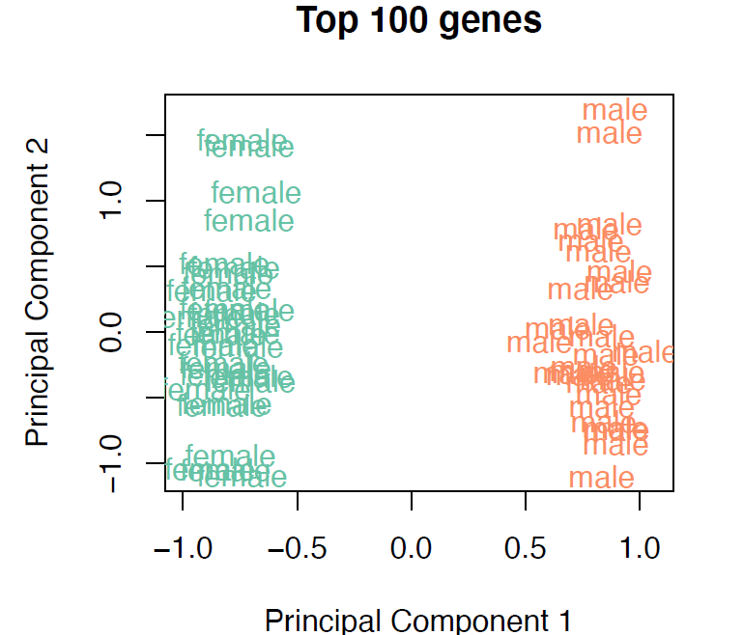

### 

Type:

1. There are outliers in both the female and male sample groups on the first scaling component (x-axis)
2. The largest dimension of variation in the top 100 genes is explained by whether a sample came from a male or a female.
3. Female samples are, in general, more similar to other female samples than they are to male samples, when considering the top 100 most variable genes.
4. The second component of variation (y-axis) separates out male from female samples.
5. The second component of variation shows that samples from males and females exhibit variation but we don’t know what explains it.

Answer:

B,C,E

### Question 5: Volcano plot

**Points**: 1

**Type**: Multiple choice

**Question**: This is a volcano plot showing sex differences in expression, with the log2(fold change (FC)) of genes plotted on the x-axis and the p-value plotted on the y-axis. Genes to the right zero on the x-axis show higher expression in females while genes to the left of zero show higher expression in males. Based on the following volcano plot, which of the following statements are true about the gene UTY:

1. UTY has a log2(FC) > 60
2. UTY has a smaller p-value than XIST, and therefore, is more statistically significant.
3. XIST has a smaller p-value than UTY, and therefore, is more statistically significant.
4. UTY has a log2(FC) <-10
5. XIST has a log2(FC) > 0
6. XIST is an X-linked gene
7. UTY is an autosomal gene

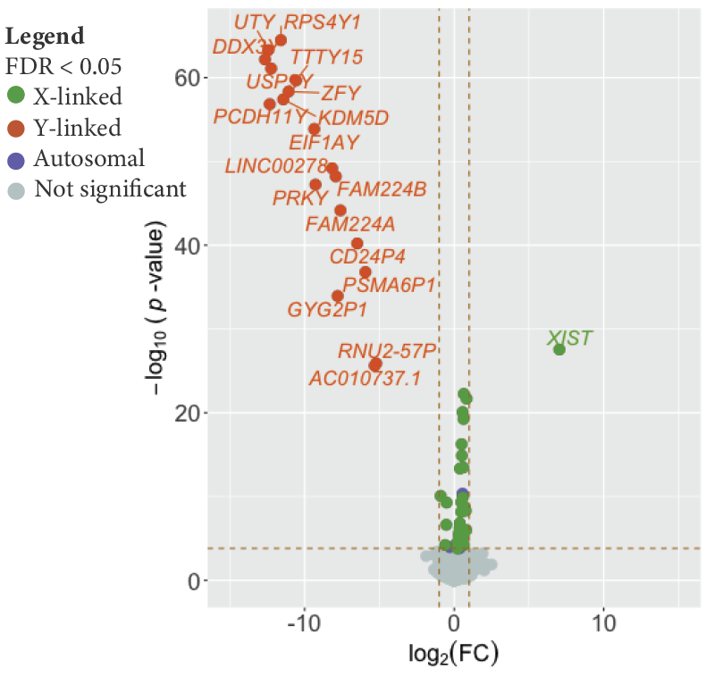

**Answer**: B, D, E, F

**Additional Text**:

### Question 6: P-values

**Points**: 1

**Type**: Multiple choice (p-value)

**Question**:

When conducting an experiment, we design our hypothesis so that we have a null hypothesis (what is the default expectation for our data) and an alternative hypothesis (what a different explanation for the data). In statistical analyses, one way to determine statistical significance is to compute a p-value. If the p-value you computed is below a chosen alpha threshold (typically 0.05), which would you do (select the correct option):

1. Accept the alternative hypothesis
2. Reject the alternative hypothesis
3. Accept the null hypothesis
4. Reject the null hypothesis
5. Conclude that you can not reject or accept the null hypothesis

**Answer**:

D. Reject the null hypothesis

**Additional Text**: In statistical frameworks we can accept or reject the null hypothesis.

### Question 7: Command line

**Points**: 1

**Type**: Multiple answer

**Question:** The code for the project is in a directory whose full path is: /data/project/placenta/RNA-seq/code/. You want to copy this code to your home directory in a directory called /home/user/code/ so that you can make edits on it and run the code with slightly different parameters. Which of the following code will work to copy the code to your home directory?

1. cd /data/project/placenta/RNA-seq/ /home/user/code/
2. cd /data/project/placenta/RNA-seq/* /home/user/code/
3. mv /data/project/placenta/RNA-seq/* /home/user/code/
4. cp /data/project/placenta/RNA-seq/ /home/user/code/
5. cp /data/project/placenta/RNA-seq/* /home/user/code/
6. cd /home/user/code/ /data/project/placenta/RNA-seq/
7. cp /home/user/code/* /data/project/placenta/RNA-seq/

**Answer**:

E. cp /data/project/placenta/RNA-seq/* /home/user/code/

**Additional Text**:

# Topic Area 3: Professional Development

### Question 1: Authorship

**Points**: 1

**Type**: Matching (6.3 Authorship/Acknowledgement)

**Question**: Author contributions mean different things in different fields, however authorship does imply contribution to the manuscript. Match the authorship title with its typical definition in our field (Biological Sciences).

| First author | Contributed primary analysis, troubleshooting, writing, and finalizing all components of the manuscript |
| --- | --- |
| Corresponding author | Person to whom communications about the manuscript (questions, comments) should be directed. |
| Senior/last author | Principal investigator of the lab, conceived the original idea for the research and/or supervised the project, obtained funding and resources. |
| Middle author | Contributed specific aspects of the work, writing, supervision, or funding of the project. |
| Acknowledgements | People who provided comments, advise, critiques, feedback on the project and/or manuscript. |

**Answer**: Match based on above.

**Additional Text**:

### Question 2: Reading a scientific paper

**Points**: 1

**Type**: Multiple Answer

**Question**: Which of the following are questions you should ask when reading a scientific paper?

1. What do the author(s) want to know (motivation)?
2. What did they do (approach/methods)?
3. Why was it done that way (context within the field)?
4. What do the results show (figures and data tables)?
5. How did the author(s) interpret the results (interpretation/discussion)?
6. What should be done next?

**Answer**: All

**Additional text:** https://journals.plos.org/ploscompbiol/article?id=10.1371/journal.pcbi.1008032#pcbi-1008032-t001

### Question 3: Writing a scientific paper

**Points**: 1

**Type**: Matching

**Question**: Please match the correct description to the term:

| Title | Subject and what aspect of the subject was studied. |
| --- | --- |
| Abstract | Summary of paper: The main reason for the study, the primary results, the main conclusions |
| Introduction | Why the study was undertaken |
| Methods and Materials | How the study was undertaken |
| Results | What was found |
| Discussion | Why these results could be significant and what the reasons might be for the patterns found or not found. |

**Answer**:

**Additional Text**:

https://writing.colostate.edu/guides/guide.cfm?guideid=83

### Question 4: Troubleshooting

**Points**: 1

**Type**: Multiple choice

**Question**: Which are options when you are coding or doing research and trying to figure out an answer to your problem?

1. For many programming tasks, others folks have posted concise, tested code to accomplish those tasks and posted them online
2. There are multiple websites where you can search for answers, including developer forums like Stack Exchange and Stack Overflow, and even YouTube
3. To compose a search for how to solve a coding problem, we should include the programming language and the words to indicate the code.
4. To compose a search for how to solve a coding problem one should put the search term in quotation marks.
5. To compose a search for how to solve an error in our code, one should put the search term in quotation marks.

**Answer**: A, B, C, E.

**Additional Text**:

# Topic Area 4: Personal Feelings

### Question 1: Unix

**Points**: 1

**Type**: Survey

**Question**: How would you describe your comfort level with using a command line interface to interact with a Linux/Unix command-line style environment?

1. Very uncomfortable
2. Uncomfortable
3. Neutral
4. Comfortable
5. Very comfortable

**Answer**: All answers accepted.

**Additional Text**:

### Question 2: R

**Points**: 1

**Type**: Survey

**Question**: How would you describe your comfort level with programming in R?

1. Very uncomfortable
2. Uncomfortable
3. Neutral
4. Comfortable
5. Very comfortable

**Answer**: All answers accepted.

**Additional Text**:

### Question 3: Programming

**Points**: 1

**Type**: Survey

**Question**: How would you describe your level of coding expertise using any programming language?

1. Novice
2. Advanced beginner
3. Competent
4. Proficient
5. Expert

**Answer**: All answers accepted.

**Additional Text**:

### Question 4: Collaboration

**Points**: 1

**Type**: Survey

**Question**: How comfortable are you asking your peers coding questions in an open class forum?

1. Very uncomfortable
2. Uncomfortable
3. Neutral
4. Comfortable
5. Very comfortable

**Answer**: All answers accepted.

**Additional Text**:

### Question 5: Reading/Interpreting Literature

**Points**: 1

**Type**: Survey

**Question**: How comfortable are you reading and interpreting a scientific paper

1. Very uncomfortable
2. Uncomfortable
3. Neutral
4. Comfortable
5. Very comfortable

**Answer**: All answers accepted.

**Additional Text**:

### Question 6: Writing

**Points**: 1

**Type**: Survey

**Question**: How comfortable are you in writing a scientific paper?

1. Very uncomfortable
2. Uncomfortable
3. Neutral
4. Comfortable
5. Very comfortable

**Answer**: All answers accepted.

**Additional Text**:

### Question 7: Research Experience

**Points**: 1

**Type**: Checkboxes

**Question**: What is your experience level doing computational research up until this point?

1. I’ve had little to no research experience
2. I have completed a course-based research experience (CURE)
3. I currently do computational research
4. I have done non-computational research
5. I have co-authored published research
6. I don’t want to do research

**Answer**: All answers accepted.

**Additional Text**:

# Post-CURE Survey questions

In a separate, anonymous survey, students can answer the following questions:

1. [MC] If you plan to apply to grad school, which degree would you immediately pursue?
   1. MS
   2. PhD
   3. MD/DO other Clinical program
   4. I am unsure if I want to attend grad school
   5. I do not plan on attending grad school
2. [OE] What was the most challenging part of taking the CURE?
3. [OE] What was the most rewarding part of taking the CURE?
4. [OE] Would you take another online GenomicsCURE?
5. [OE] Would you recommend taking a GenomicsCURE to another online student?

Check boxes

List certain skills in likert

Using challenges - do you feel like you improved

Which challenges you experienced

How did you address the challenges (add blank)

Feature: Challenging or rewarding?

1. [Likert] How effective were the following (if you attended):
   1. Slack
   2. Course video recordings
   3. Lab meetings
   4. Lab meeting recordings
   5. Writing hours
   6. Shared research hours